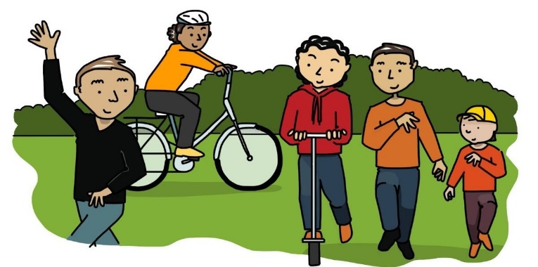
#letskeepmoving
Click or tap here to enter Council name.
Click or tap here to enter street address 1
Click or tap here to enter street address 2.
Enter suburb
Enter postcode.
Enter state/territory.

Tuesday, 18 August 2020

To the Mayor, Councillors and staff,

This year has been challenging for us all as we deal with the restrictions necessary to stop COVID-19 and return to normal life.
We have responded to coronavirus lockdown by getting out more in our community to walk, scoot and ride with our families and loved ones. This has helped us maintain some physical activity and connection with our community. We have used our local footpaths and bikeways a lot more and we have a much greater appreciation of the value they have in allowing us to get to shops, parks and other key locations but we have been concerned at times by the lack of space to keep a safe distance from others.
We are also more aware of how much easier it could be if some of the gaps and difficult crossings could be fixed and if paths were wider to allow more people to safely get around in our community.
We strongly support having better footpaths for walking and bikeways for our children to ride to school safely and for all of us to access our locals shops, recreation areas and services.
Could you please reply and tell me what Council plans are to expand and improve our walking and cycling paths, especially during this difficult time as we deal with the coronavirus?
Many thanks,
 | Click or tap here to enter your name.
My contact details for reply: | Click or tap here to enter your email and/or address.

